# [AWS Certified Solutions Architect - Associate](https://youtu.be/Ia-UEYYR44s)

# Topics

1. S3
2. Snowball
3. VPC
4. VPC END POINTS
5. VPC FLOW LOGS
6. NACL
7. SECURITY GROUPS
8. NAT
9. VPC Follow Along
10. IAM
11. COGNITO
12. AWS CLI & SDK
13. DNS
14. ROUTE 53
15. EC2
16. EC2-PRICING
17. AMI
18. ELB
19. EC2 FOLLOW Along
20. (Elastic) File System (EFS)
21. (Elastic) Block Store (EBS)
22. CloudFront

S3:

Simple Storage Service stores data in object forms as compared to file systems or block storage , s3 objects store files 0 bytes to 5 terabytes in size. S3 buckets holds objects which can have folders as well

Storage Classes:

* Standard
* Intelligent Tiering
* Standard Infrequently Accessed(IA)
* One Zone IA
* Glacier
* Glacier Deep Achieve

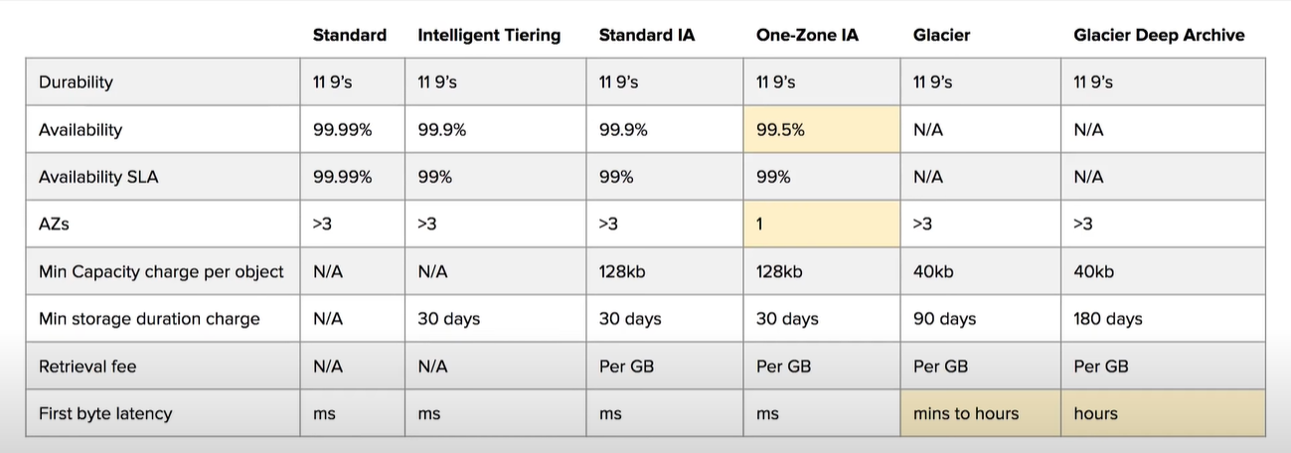

S3 Security:

All new buckets are private by default, and can be set by using policy set systax or from options menu

S3 Encryption:

Encryption in trasit is done with ssl,tls

Encryption at rest uses sse-aes,sse-kms,sse-c

Client-side Encryption by encrypting our files before uploading

S3 dataconsistency:

New object (Read after Write)

Overwrite or delete objects (eventual)

S3 cross region replication:

Replication of data into another region’s bucket, if versioning is on data can be replicated into another account

S3 Versioning:

S3 objects versions with ids

S3 lifecycle management:

To change s3 storage classes after a period

S3 transfer acceleration:

Upload on edge location(datacenter closer to us) rather uploading on a s3 bucket

S3 pre assigned url:

It can be generated by commands cli or aws sdk for private files

S3 MFA delete:

Require mfa code to delete s3 objects

Snow ball:

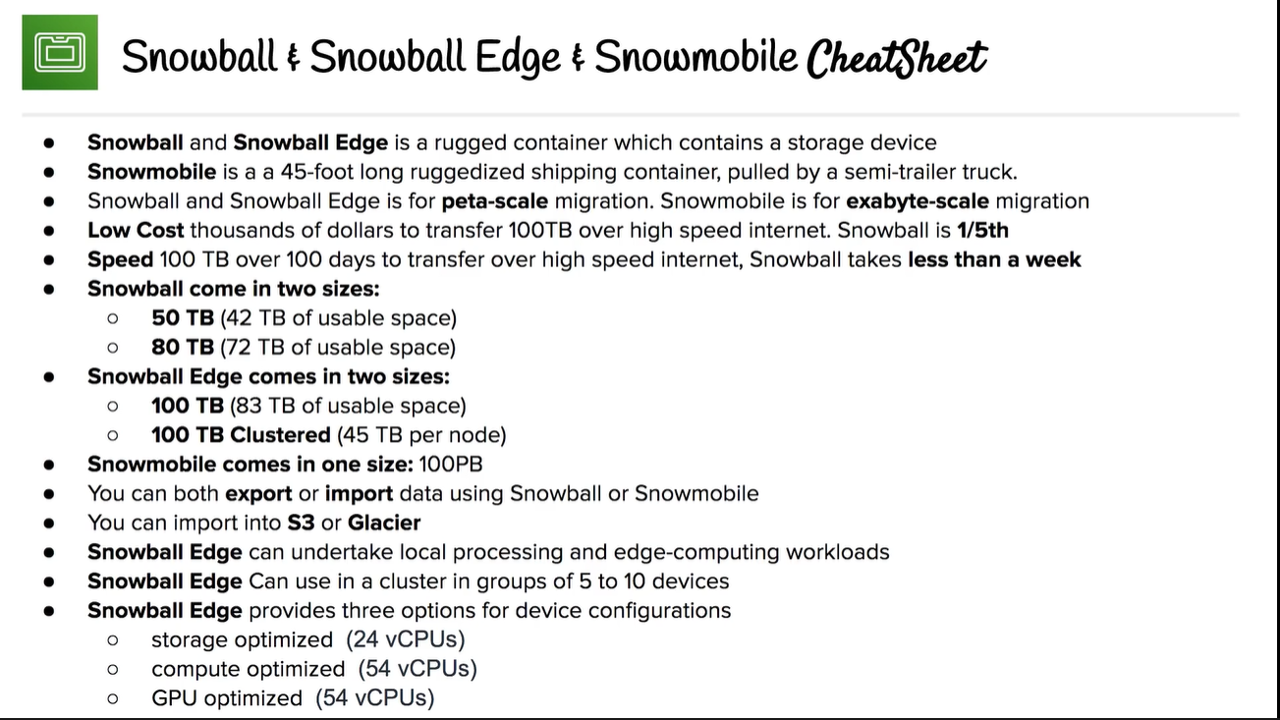

VPC:

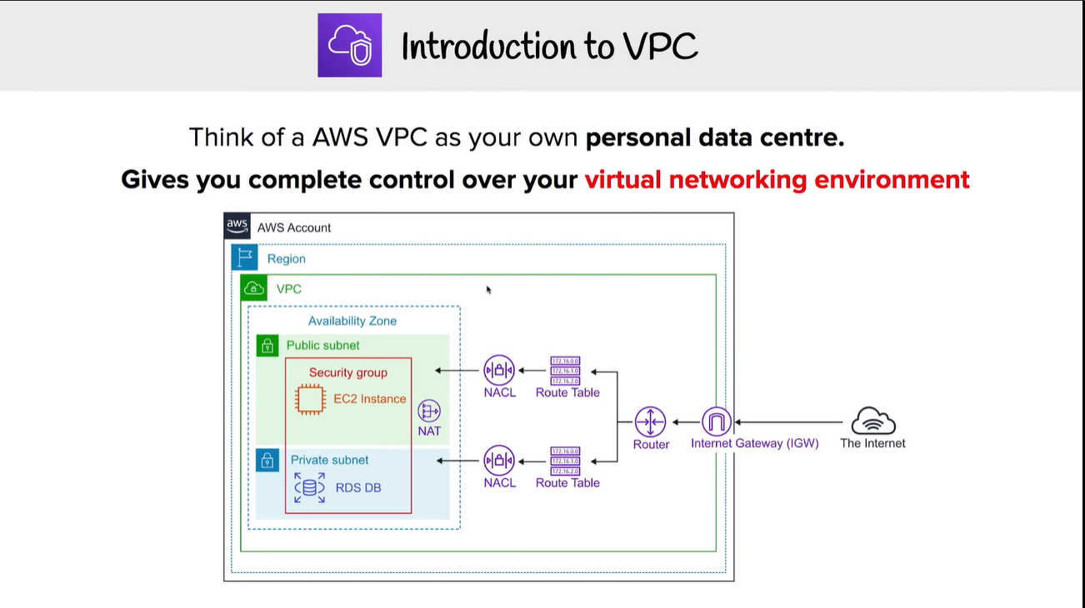

VPC EndPoint:

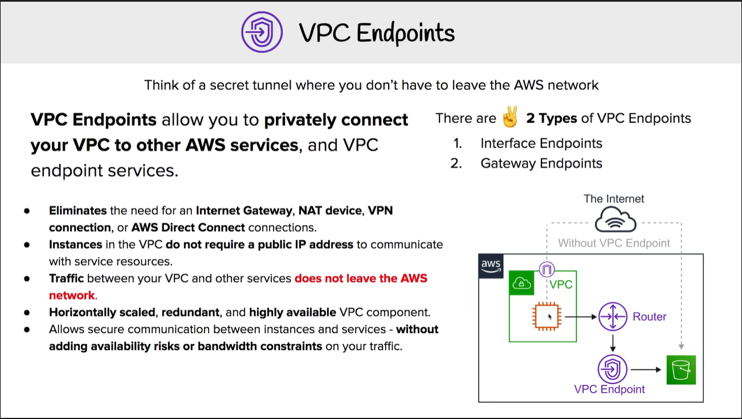

VPC FLOW LOGS:

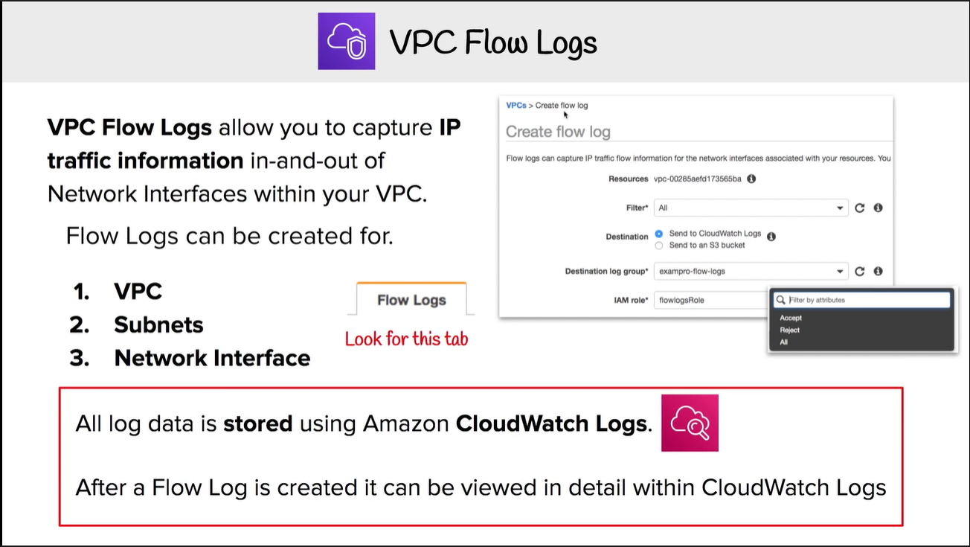

NACL:

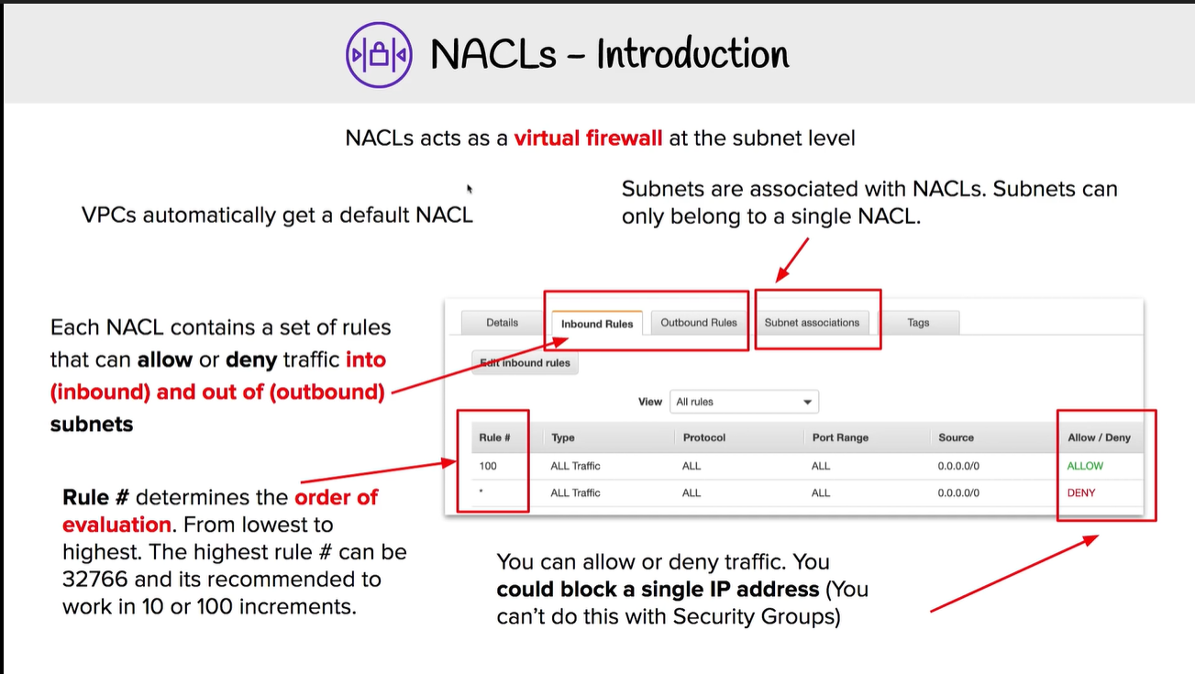

Security Groups:

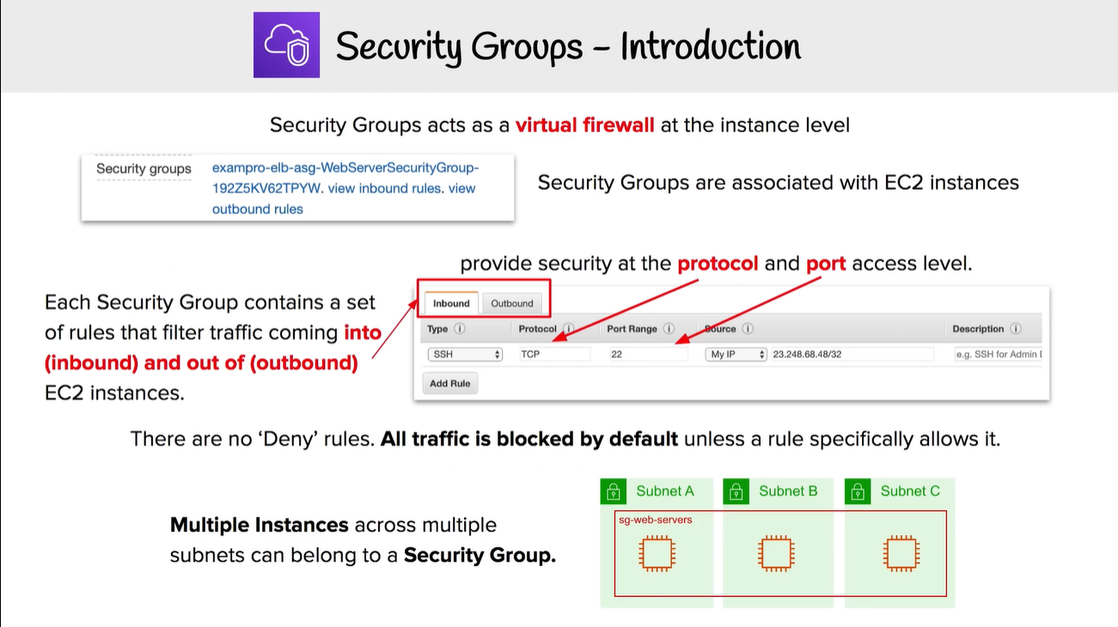

NAT:

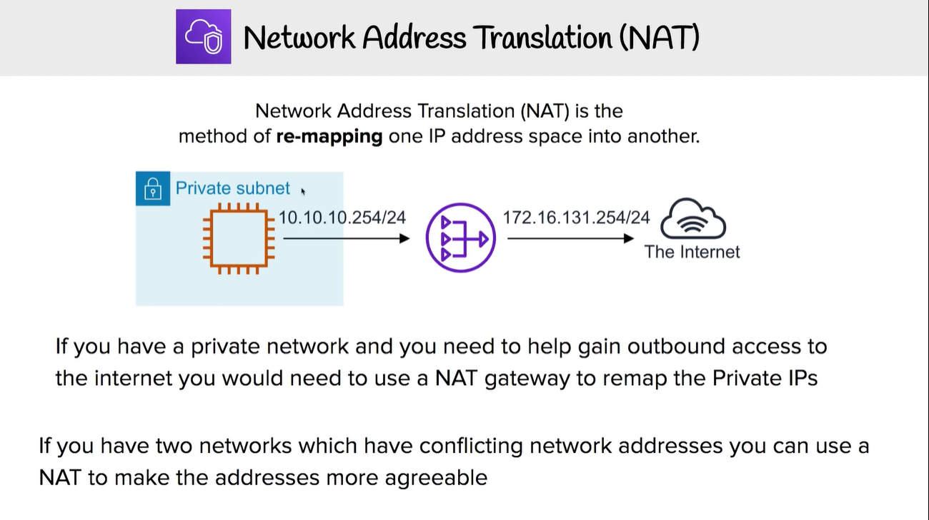

IAM:

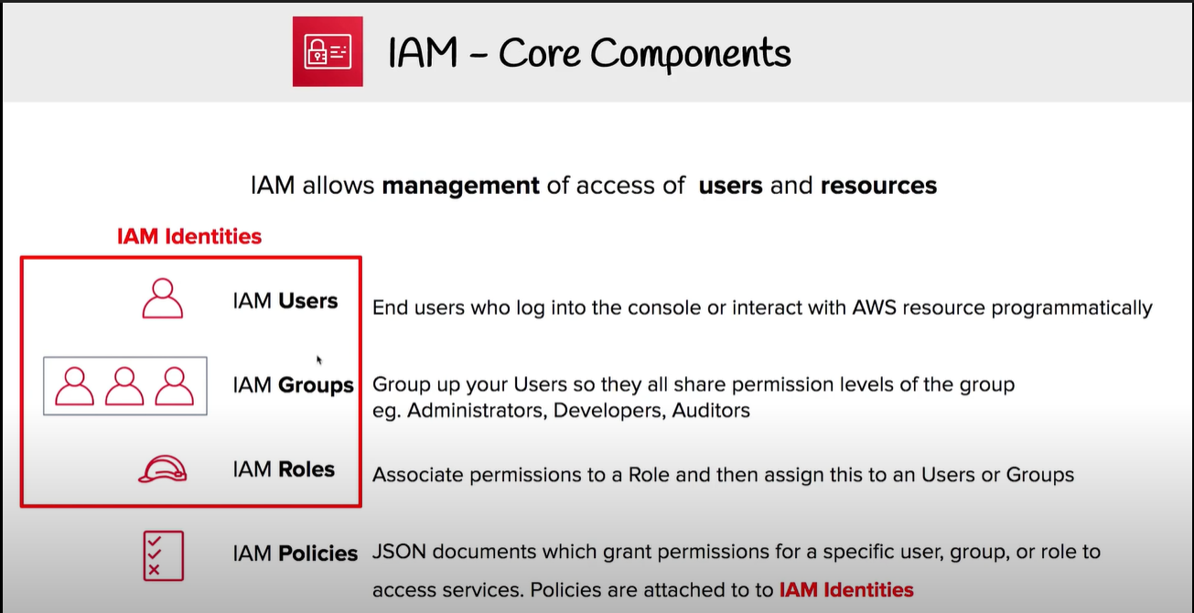

Cognito:

